Student:

A1. Concepts of power quality

1. **Explain with your own words:**
2. Quality of supply.
3. Current quality.

**Download the UNE-EN IEC 61400-21** *Wind energy generation systems -* ***Part 21-1****: Measurement and assessment of electrical characteristics - Wind turbines*

* Access standards by means UPC / Bibliotècnica / Localización de legislación, normativa, patentes y marcas / Normas UNE AENOR.

You can use the following link:

<https://plataforma-aenormas-aenor-com.recursos.biblioteca.upc.edu/>

* Select your **User type**
* Click on **Send** button.

Select: ‘*Buscador de normas****’*** and search and open the standard **IEC 61400-21**:

*Código:*61400-21

1. **Summarize (shortly) the contents of the standard. According to the standard, when a wind turbine will disconnect from the network?**
2. **Explain with your own words, what is the “fault ride-through”**
3. **Compare the “fault ride-through” requirements specified by different countries.**

# Quality of supply:

In the context of this Master´s (MUSAE), **supply** refers to the electric power provided to a system.  
With the term **quality** we refer to reliability and stability of this supply that directly impacts the proper operation and safety of the electrical equipment on the receiving side.  
Quality of Supply measurements can be divided into Current and Voltage Quality, even while both being closely related and interdependent (trough line impedance) , they both have different impact In the Quality of supply thus the regulation tolerances are different for each one.  
  
As seen in class, within the concept “**Supply Quality**” we differentiate various components with some of the critical ones being Harmonics distortion, Grid frequency, Flickers and voltage dips/sags.

# Current Quality:

Contained within “Quality of supply” definition, specially focuses on the characteristics of the electrical current waveform. More specifically, how much the real Current wave deviates from the ideal sinusoidal with constant amplitude, frequency, and a zero-phase (matching the one from the voltage wave).

A poor Current Quality normally relates to big EMC emissions, furthermore, if the line impedance is not low enough a low Current Quality will leak back and affect the voltage Quality perceived by closer devices.

# Summarize IEC 61400-21, when would a wind turbine have to be disconnected from the network?

IEC 61400-21 provides guidelines on power performance assessment for wind turbines, with test methodologies and examples.  
Compliance with this standard is crucial to maintain grid stability and correct integration within the Spanish electrical system (and many others).  
  
Taken from the page 67 of the standard: the turbine must disconnect from the grid for a predetermined amount of time in the event of over/under voltages and over/under frequency.

More specifics about exact tolerances and disconnection times can be found in table 14 “Grid protection tests.”

# Fault ride-trough:

(FRT) It refers to the capability of any electrical generator to remain connected to the electrical grid and continue its operation even when there is a short-term electrical fault such as undervoltage (UVRT) or overvoltage (OVRT).

Grid tolerances like FRT or harmonic distortions are usually defined separately for unbalanced and balanced loads.

UVRT and OVRT requirements for Spanish wind turbines are both specified in IEC 61400-21.

# Compare FRT from different countries:

Both Spanish and German regulation define FRT curves indicating how much and for how long should any generation system tolerate FRT before disconnection.

The German FRT regulation (VDE-AR-N 4120:2017-05) describes two situations regarding the type fault:

* Balanced faults or Modules type 1: (less common) in this case, power generating plants must adhere to a stricter FRT curve (lower time limit for same voltage threshold)  
    
  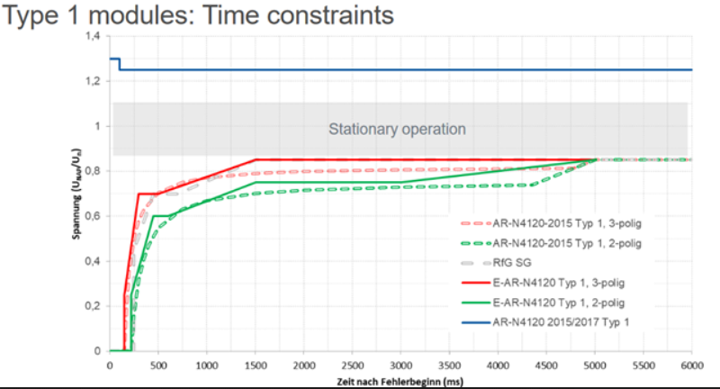
* Unbalanced faults or Modules type 2: (more common) they have a more flexible FRT.  
  The time limit for faults is way more forgiving than type 1, there is a lot more room above the curves for faults to happen.  
    
  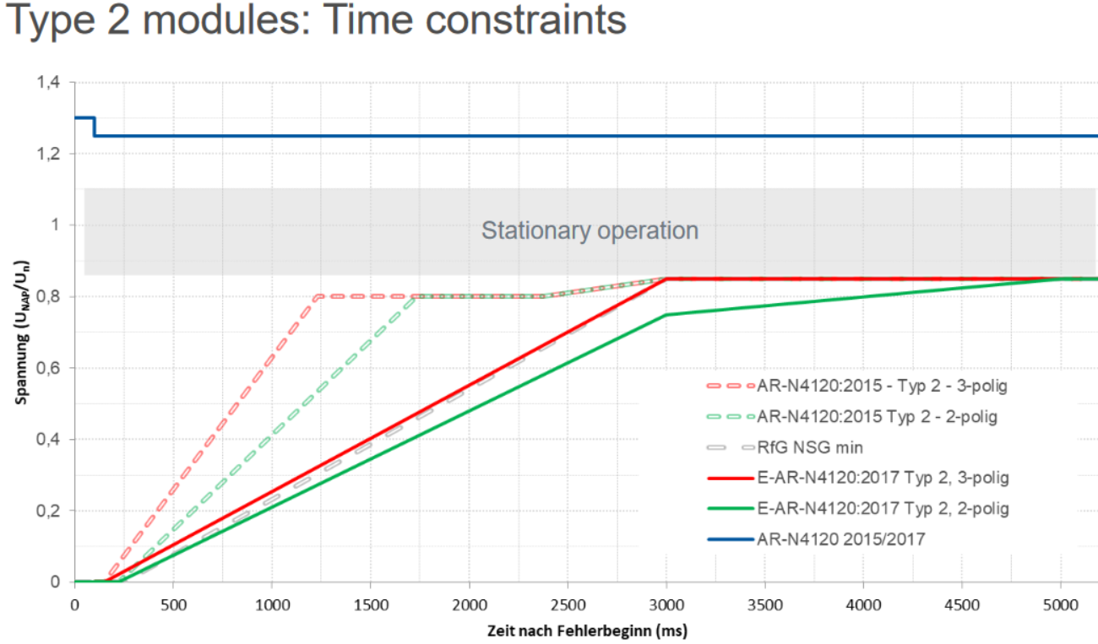

On similar terms the Spanish regulation (BOE A07405-07430) doesn’t discriminate between balanced and unbalanced faults.  
The curve allows for more flexible faults in general compared to its German counterpart.

